Github Actions



Building Blocks of Pipeline
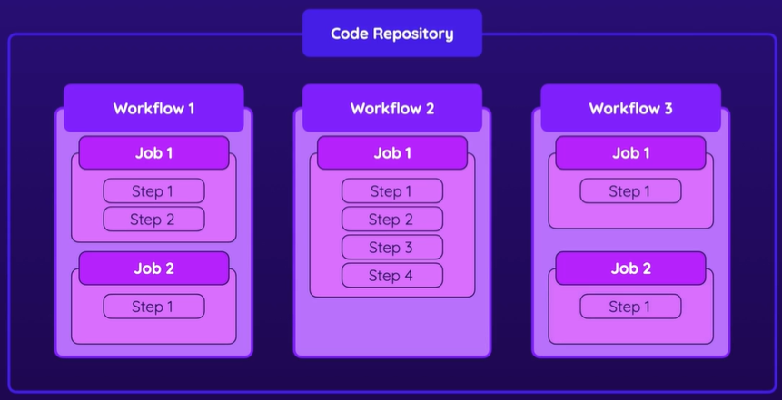

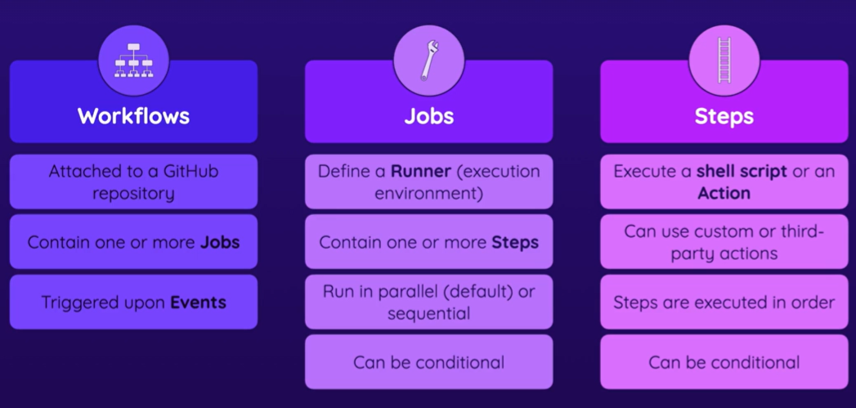
Workflow
- attached to a Github repository
- triggered upon events
Job
  - can run parallely, sequelly
  - runs on condition
Steps – executes shell script, actions
    - runs sequelly
    - runs on condition
Actions – a predefined application/script that performs a task
uses: actions/action_name
with:
configurations

npm: node package manager installed along with node js, to manage packages and dependencies(including indirect dependencies for the packages and dependencies).
npm install:
installs dependencies specified in package.json and updates the (version in)package-lock.json
- ❎may mess up the versions
npm ci:- clean install
installs dependencies specified exactly in the package-lock.json
Event Jobs{Job1[Steps]_{Runs on: Runner1}, Job2[Steps] _{Runs on: Runner2},..}—Explanation

